JAWAHARLAL NEHRU TECHNOLOGICAL UNIVERSITY KAKINADA
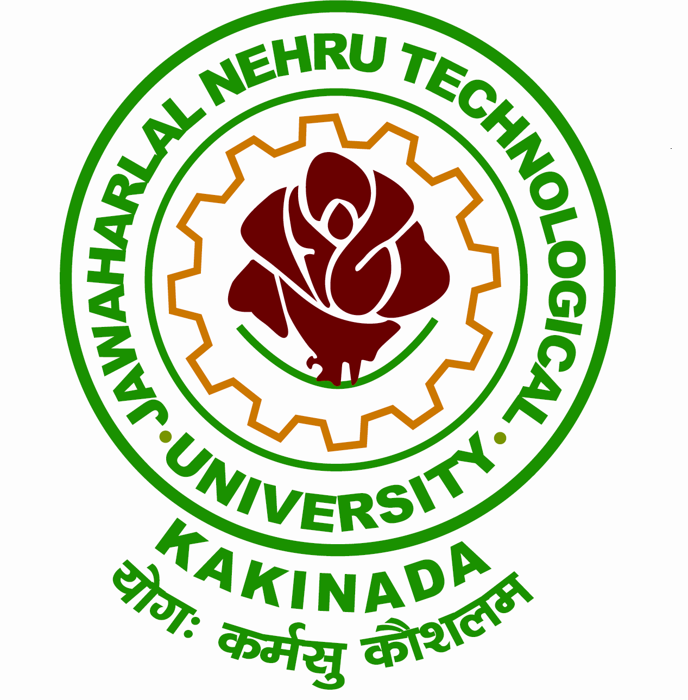
KAKINADA-533 003, Andhra Pradesh, India
UNIVERSITY EXAMINATION CENTER
e-Procurement Tender Notice
Tender Notice No. JNTUK/UECK/Printing and Supply of Answer Booklets &Various Certificates items/2020-21/1; Date:23/06/2020
S.No. | Description | Tender ID
1 | Printing and Supply of Answer Booklets and Various certificates for utilization in University Examination Center, JNTUK, Kakinada | 339773
The bidders can view /down load from www.apeprocurement.gov.in Further details contact at Office of the Director of Evaluation, UEC, JNTUK. Sd/- Director of Evaluation Ph.0884-2300911.

