***One Day National Level***

Faculty Development Programme

**On**

**Block Chain –The Modern Internet**

16th August2018

(9 AM – 5 PM)

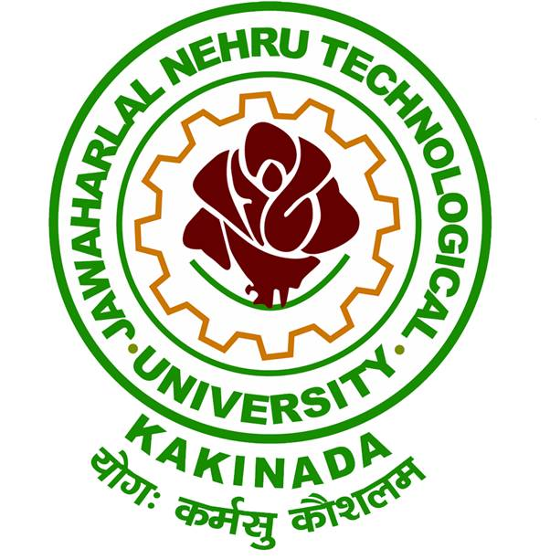

**Organized by**

**Directorate of Incubation Center**

**Jawaharlal Nehru Technological University, Kakinada-533 003**

**Andhra Pradesh, India.**

**CHIEF PATRON**

**Prof. S. Rama Krishna Rao**

Hon’ble Vice Chancellor (I/C), JNTUK, Kakinada

**PATRONS**

**Dr. K. Purnanandam**

Rector, JNTUK, Kakinada

**Dr. V.V. Subba Rao**

Registrar, JNTUK, Kakinada

**Dr. G.V.R. Prasada Raju**

Principal, UCEK, JNTUK, Kakinada

**CONVENOR**

**Dr. J. V. R. Murthy**

Professor & Director Incubation Centre,

UCEK, JNTUK, Kakinada

**COORDINATOR**

**Mr. S. Chandra Sekhar**

Assistant Professor & TPO,

UCEK, JNTUK, Kakinada

**ORGANIZING COMMITTEE**

Dr. K. V. Ramana, Professor

Dr. Ch. Satyanarayana, Professor

Dr. L. Sumalatha, Professor

Dr. MHM. Krishna Prasad, Professor

Dr. A. Krishna Mohan, Professor

Dr. K. Sahadevaiah, Professor & HoD CSE

Dr. D. Haritha, Professor

Dr. O. SreenivasaRao, Professor

Dr. N. Ramakrishnaiah, Assoc. Professor

Mrs. SSSN. UshaDevi, Asst. Professor

Mrs.A. Karuna, Asst. Professor

Mrs. E. Suneetha, Asst. Professor

**ABOUT THE UNIVERSITY**

Jawaharlal Nehru Technological University Kakinada is formed in the year 2008. University College of Engineering, Kakinada, is one of the constituent colleges of this University playing a significant role since 1946 in imparting technological education in the state of Andhra Pradesh. It is located in the coastal districts of Andhra Pradesh having nearly 300 Engineering Colleges affiliated to this University. The college won appreciation for judicious effective utilization of TEQIP - I & II funds and is presently under TEQIP - III to enhance PG education and Research.

**ABOUT INCUBATION CENTER, JNTUK**

The Vision of JNTUK Incubation Center is to provide effective and innovative global solutions to local problems by coordinating Government, Industry and Academia, that helps enhancing the quality of Education, Professional Skills, Employability and Per Capita Income.

The Incubation Center has collaboration with Wipro Ltd., TRUZIO Technologies Ltd. Tooople Pte. Ltd. Singapore, Tetrasoft Inc, St. Louis, MO, USA, and tie up with Andhra Electronics Ltd. and few other companies are in pipeline.

Wipro Ltd. will be training the students of JNTUK in the areas of Machine Learning, IoT and Big Data Analytics. They encourage and fund the start ups in the above areas.

TRUZIO and JNTUK are developing Educational ERP package for the process automation from admission till award of the degree. As a part of it some modules such as Grievances Monitoring System for the University Examination Section were developed.

Toople Pte. Ltd., Singapore is supporting students of JNTUK by introducing cutting edge technologies and platforms such as Block Chain, IoT, AI / Machine Learning.

Tetrasoft Inc, St. Louis, MO, USA will open the network connectivity so that individual students and professionals can join the virtual projects development teams independently to contribute to solutions development and enhance their skills for better employment.

One Day National FDP on

**Block Chain - The Modern Internet**

**REGISTRATION FORM**

Name :

Designation :

Organization :

Address :

Contact Number :

E-mail :

I would like to participate.

**Signature**

**ADDRESS FOR CORRESPONDENCE**

**Directorate of Incubation Center,**

**Jawaharlal Nehru Technological University,**

**Kakinada - 533003**

**East Godavari District,**

**Andhra Pradesh, India.**

**ABOUT THE PROGRAM**

The blockchain is an undeniably ingenious invention – the brainchild of a person or group of people known by the pseudonym, [Satoshi Nakamoto](https://en.wikipedia.org/wiki/Satoshi_Nakamoto). But since then, it has evolved into something greater, and the main question every single person is asking is: What is Blockchain?

By allowing digital information to be distributed but not copied, blockchain technology created the backbone of a new type of internet. Originally devised for the digital currency, Bitcoin, the tech community is now finding other potential uses for the technology.

**TOPICS BEING COVERED**

* What is Block Chain?
* Features of Block Chain.
* Security aspects of Block Chain
* Real time applications of Block Chain
* Use Case on Crypto Currency
* Use Case on Smart Contracts
* Use Case on Land Registry Management
* Use Case on Citizen Identity Management
* Use Case on Healthcare Management
* Use Case on Hospitality Management

**DATE**

**16 Aug 2018**

**9 am to 5 pm**

**RESOURCE PERSON**

**Prof. NMK. Bhatta**

Distinguished Alumni of JNTUK, Professor & Dean (Research) Xavier Institute of Management & Entrepreneurship and former Global Head Business Excellence TCS Ltd. and Former Professor Information Systems at Indian Institute of Management Indore

**PROGRAM FEE DETAILS**

**No registration fee**

**For online Registration:**

<https://goo.gl/RA6qup>

**Last date for online registration:**

**13th August 2018**

**Spot registrations are allowed**

**CONTACT DETAILS**

**Mr. B. Suraj Aravind**

Assistant Professor (C)

CSE, UCEK, JNTUK

Mobile: **+91-9849510226**

Email: fdpjntuk@gmail.com