***One Day National Level***

Faculty Development Programme

**On**

**Cloud Computing**

**&**

**Cyber Security**

13th March2018

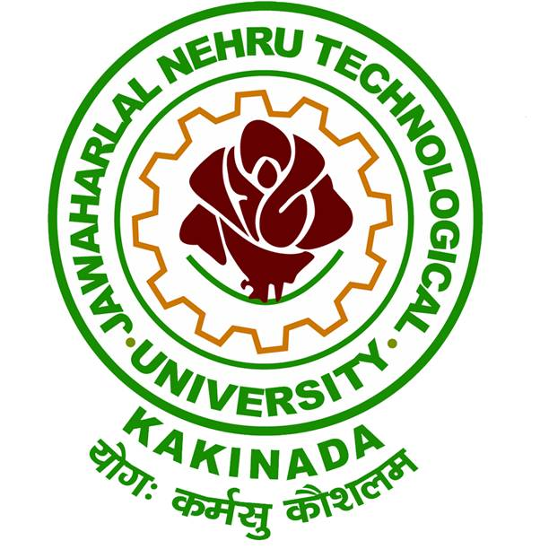

**Organized by**

**Directorate of Incubation Center**

**Jawaharlal Nehru Technological University, Kakinada-533 003**

**Andhra Pradesh, India.**

**CHIEF PATRON**

**Prof. V. S. S. Kumar**

Hon’ble Vice Chancellor, JNTUK, Kakinada

**PATRONS**

**Dr. K. Purnanandam**

Rector, JNTUK, Kakinada

**Dr. V.V. Subba Rao**

Registrar, JNTUK, Kakinada

**Dr. D. Koteswara Rao**

Director, Faculty Development Center,

JNTUK, Kakinada

**Dr. G.V.R. Prasada Raju**

Principal, UCEK, JNTUK, Kakinada

**CONVENORS**

**Dr. J. V. R. Murthy**

Professor & Director Incubation Centre,

UCEK, JNTUK, Kakinada

**Dr. A. S. N. Chakravarthy**

Professor & MOOCS Coordinator,

UCEK, JNTUK, Kakinada

**COORDINATORS**

**Smt. A. Karuna**

Assistant Professor,

Dept of CSE, UCEK, JNTUK, Kakinada

**Smt. E. Suneetha**

Assistant Professor,

Dept of CSE, UCEK, JNTUK, Kakinada

**ORGANIZING COMMITTEE**

Dr. K. V. Ramana, Professor

Dr. Ch. Satyanarayana, Professor

Dr. L. Sumalatha, Professor

Dr. MHM. Krishna Prasad, Professor

Dr. A. Krishna Mohan, Professor

Dr. K. Sahadevaiah, Professor & HoD CSE

Dr. D. Haritha, Professor

Dr. O. SreenivasaRao, Assoc. Professor

Mr. N. Ramakrishnaiah, Assoc. Professor

Mr. S. Chandra Sekhar, Asst. Professor

Mrs. SSSN. UshaDevi, Asst. Professor

**ABOUT THE UNIVERSITY**

Jawaharlal Nehru Technological University Kakinada is formed in the year 2008. University College of Engineering, Kakinada, is one of the constituent colleges of this University playing a significant role since 1946 in imparting technological education in the state of Andhra Pradesh. It is located in the coastal districts of Andhra Pradesh having nearly 300 Engineering Colleges affiliated to this University. The college won appreciation for judicious effective utilization of TEQIP - I & II funds and is presently under TEQIP - III to enhance PG education and Research.

**ABOUT INCUBATION CENTER, JNTUK**

The Vision of JNTUK Incubation Center is to provide effective and innovative global solutions to local problems by coordinating Government, Industry and Academia, that helps enhancing the quality of Education, Professional Skills, Employability and Per Capita Income.

The Incubation Center has collaboration with Wipro Ltd., and TRUZIO Technologies Ltd., tie up with Andhra Electronics Ltd. and few other companies are in pipeline.

Wipro Ltd. will be training the students of JNTUK in the areas of Machine Learning, IoT and Big Data Analytics. They encourage and fund the start ups in the above areas.

TRUZIO and JNTUK are developing Educational ERP package for the process automation from admission till award of the degree. As a part of it some modules such as Grievances Monitoring System for the University Examination Section were developed.

One Day National FDP on

**Cloud Computing & Cyber Security**

**REGISTRATION FORM**

Name :

Designation :

Organization :

Address :

Contact Number :

E-mail :

I would like to participate.

**Signature**

**ADDRESS FOR CORRESPONDENCE**

**Directorate of Incubation Center,**

**Jawaharlal Nehru Technological University,**

**Kakinada - 533003**

**East Godavari District,**

**Andhra Pradesh, India.**

**ABOUT THE PROGRAM**

Cloud computing is an information technology  paradigm that enables ubiquitous access to shared pools of configurable system resources and higher-level services that can be rapidly provisioned with minimal management effort, often over the Internet. Cloud computing relies on sharing of resources to achieve coherence and economies of scale, similar to a public utility.

Cyber Security includes controlling physical access to the hardware, as well as protecting against harm that may come via network access, data and code injection.

This FDP aims to discuss the features of Cloud Computing and its applications in the real world and Cyber Security with case studies.

**TOPICS BEING COVERED**

* Features of Cloud computing
* Cyber Security in Cloud
* Real time applications of Cloud
* Case Study on Cyber Security

**RESOURCE PERSON**

**Prof. M.N. Bhatta**

Distinguished Alumni of JNTUK, Professor of Information Systems, IIM Indore and former Global Head Business Excellence TCS Ltd.

**PROGRAM FEE DETAILS**

**No registration fee**

**For online Registration:**

https://goo.gl/SALzge

**Last date for online registration:**

**12th March 2018**

**Spot registrations are allowed**

**CONTACT DETAILS**

**Mr. B. Suraj Aravind**

Assistant Professor (C)

CSE, UCEK, JNTUK

Mobile: **+91-9849510226**

Email: fdpjntuk@gmail.com