***A Five Day National Level***

Faculty Development Programme

**On**

**Internet of Things**

**&**

**Advanced Analytics**

1st - 5th Dec*,* 2017

**(Sponsored by TEQIP-III & Supported by CSI)**

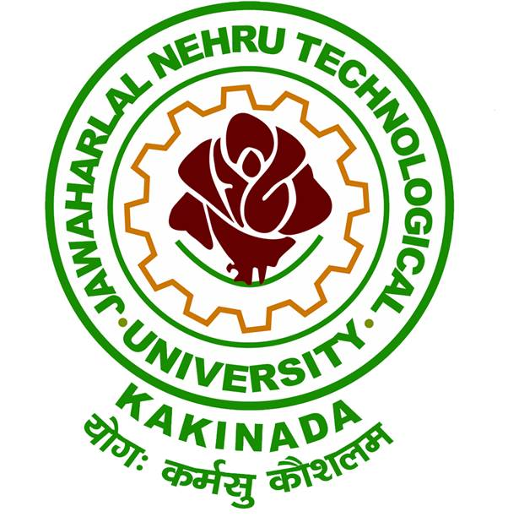

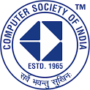

**Organized by**

**Department of Computer Science and Engineering**

**University College of Engineering Kakinada (A)**

**JNTUK, Kakinada -533 003**

**Andhra Pradesh, India.**

**CHIEF PATRON**

**Prof. V. S. S. Kumar**

Hon’ble Vice Chancellor, JNTUK, Kakinada

**PATRONS**

**Dr. K. Purnanandam**

Rector, JNTUK, Kakinada

**Dr. V.V. Subba Rao**

Registrar, JNTUK, Kakinada

**Dr. G.V.R. Prasada Raju**

Principal, UCEK, JNTUK, Kakinada

**CONVENORS**

**Dr. J. V. R. Murthy**

Professor & Director Incubation Centre,

UCEK, JNTUK, Kakinada

**Dr. M. H. M. Krishna Prasad**

Professor & Coordinator TEQIP-III,

UCEK, JNTUK, Kakinada

**COORDINATORS**

**Dr. A.S.N. Chakravarthy**

Professor of CSE,

JNTUK, Kakinada.

**Mr. S. Chandra Sekhar**

TPO & Assistant Professor

CSE, UCEK, JNTUK

**CSI COORDINATING COMMITTEE**

**Mr. Seshu Kumar GV,** Vice Chairman, CSI Hyderabad

General Manager, Wipro Technologies

**Rajive Ranjan Kumar**, Secretary CSI Hyderabad,

Senior Project Manager, Wipro Technologies

**Vijay Satyavolu**, Program Convenor FDP programs, CSI Hyderabad

Program Manager Wipro Technologies

**ORGANIZING COMMITTEE**

Dr. K. V. Ramana, Professor

Dr. Ch. Satyanarayana, Professor

Dr. L. Sumalatha, Professor

Dr. A. Krishna Mohan, Professor & HoD

Dr. K. Sahadevaiah, Professor

Dr. D. Haritha, Professor

Dr. O. SreenivasaRao, Assoc. Professor

Mr. N. Ramakrishnaiah, Assoc. Professor

Mrs. SSSN. UshaDevi, Asst. Professor

Mrs. E. Suneetha, Asst. Professor

Mrs. A. Karuna, Asst. Professor

**ABOUT THE COLLEGE**

Jawaharlal Nehru Technological University Kakinada is formed in the year 2008. University College of Engineering, Kakinada, is one of the constituent colleges of this University playing a significant role since 1946 in imparting technological education in the state of Andhra Pradesh. It is located in the coastal districts of Andhra Pradesh having nearly 300 Engineering Colleges affiliated to this University. The college won appreciation for judicious effective utilization of TEQIP - I & II funds and is presently under TEQIP - III to enhance PG education and Research.

**ABOUT THE DEPARTMENT**

The Department of Computer Science& Engineering at University College of Engineering Kakinada is formally established in 1989.It has NBA accreditation and TEQIP – III grant for promoting research. The labs are equipped with state of art technology. The faculty are specialized in the areas of Data Mining, Image Processing, Information Security and Computer Networks. The department aims at promoting industry oriented research. It has MoU with TCS Ltd, Chicago State University and Loment Technologies Ltd., USA for joint research collaboration.

**ABOUT CSI**

Formed in 1965, the CSI has been instrumental in guiding the Indian IT industry down the right path since its formative years. CSI has 70 chapters all over India, 418 student branches and more than90000 members including India's Leaders from the IT industry, brilliant scientists and dedicated academicians.

A Five Day National FDP on

**Internet of Things & Advanced Analytics**

**(Sponsored by TEQIP-III & Supported by CSI)**

**REGISTRATION FORM**

Name :

Designation :

Organization :

Address :

Contact Number :

E-mail :

Accommodation needed? (Yes / No)

I would like to participate as a Faculty/PG Student.

**Signature**

**ADDRESS FOR CORRESPONDENCE**

**Mr. S. Chandra Sekhar**

TPO & Assistant Professor

CSE, UCEK, JNTUK, Kakinada – 533003

**ABOUT THE WORKSHOP**

Businesses have increased the usage of Internet of Things(IoT) and Analytics in recent years causing a spike in the demand of trained professionals. IoT can connect devices embedded in various systems to Internet and capture more data increasing efficiency, improving performance through IoT analytics and IoT Security. Big data analytics uses a diverse mix of statistics, machine learning, algorithm and visualization.

**TOPICS BEING COVERED**

* Building IoT using Raspberry Pi
* Design secure IoT, IoT on Cloud
* Real Time Case Study
* Data Science world & Opportunities
* Statistical Techniques
* Descriptive, Predictive Analytics
* Machine Learning.
* Managing and Understanding data in "R"
* Visualization & Insight with Tableu
* Case Studies & Real-Life Problems

**RESOURCE PERSONS**

**Team from CSI Hyderabad and Corporates**

**PROGRAM FEE DETAILS**

**Registration Fee: Rs.500/- in the form of cash payable on the first day of the programme.**

**Note: No fee for participants from TEQIP-III aided institutions.**

**For online Registration:**

https://goo.gl/o4UwYN

Note : Accommodation is given on payment basis.

**Last date for online registration:**

**30th November 2017**

**CONTACT DETAILS**

**Dr. A.S.N. Chakravarthy**

Professor of CSE,

JNTUK, Kakinada.

Mobile: **+91-9618719229**

Email: drasnchakravarthy@yahoo.com

**Mr. S. Chandra Sekhar**

TPO & Assistant Professor

CSE, UCEK, JNTUK

Mobile: **+91-9885258544**

Email: chandrasekhar.s@jntukcek.ac.in