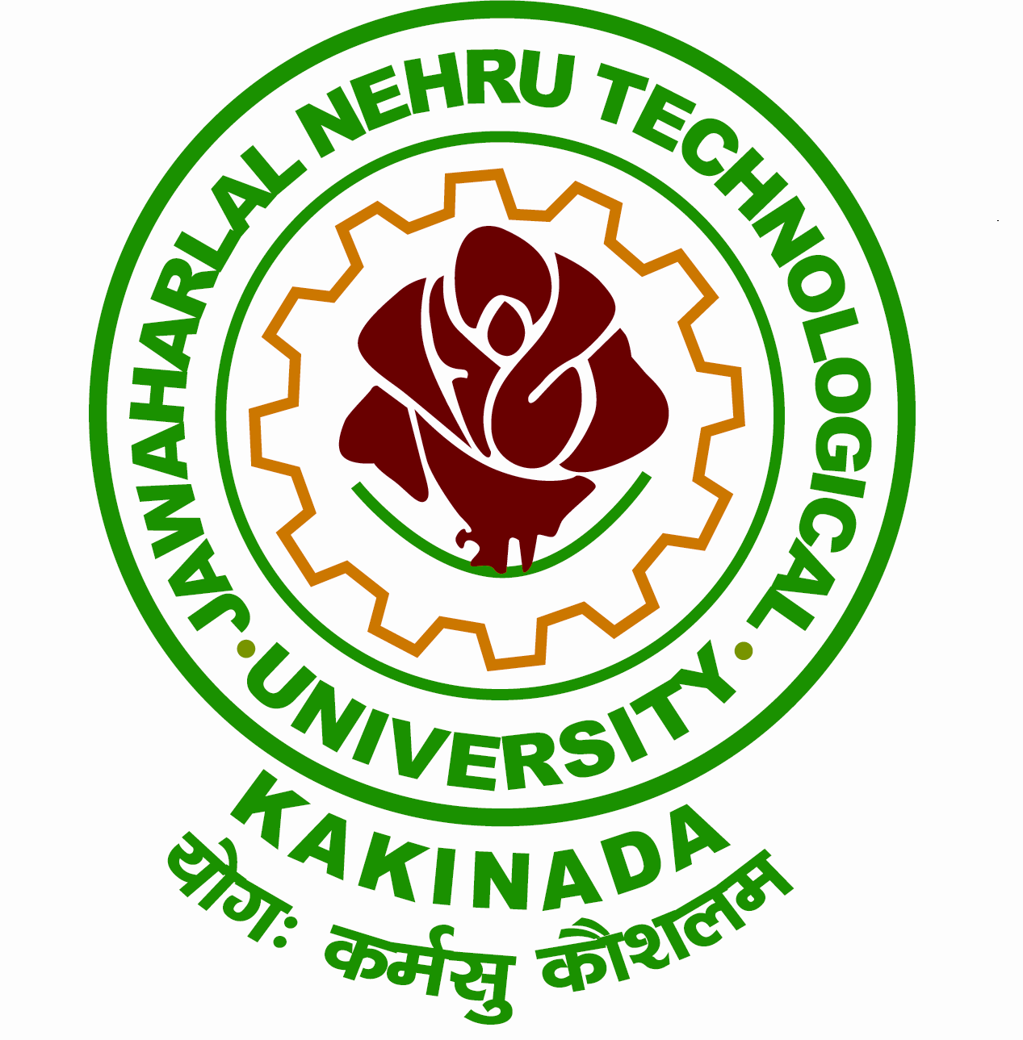
Grams: “TECHNOLOGY” Office : 0884-2340356 Email: dajntukakinada@gmail.com Mobile :+91 7093674555
Directorate of Admissions
JAWAHARLAL NEHRU TECHNOLOGICAL UNIVERSITY KAKINADA
KAKINADA-533003, Andhra Pradesh, INDIA

Lr.No.JNTUK/Admissions/MBA/Sponsored/MBA(CMU)/Convener/Spot-Admissons- Counseling Schedule -2017-18 Date: 07-10-2017

Dr. M. RAMALINGA RAJU
M.Tech , Ph.D.
Professor of EEE & Director of Admissions

CIRCULAR
The counseling for Spot admissions into MBA(general) regular, convener category and sponsored category and MBA(CMU) courses counseling for the academic year 2017-18 offered at JNTUK, Kakinada will be conducted in SENATE HALL in the Administrative Building as per the following schedule
COUNSELING SCHEDULE

Date | Time | Fee details for MBA(CMU)& MBA(Sponsored) | Fee details for MBA(Regular) Convener category under Spot admissions
07-10-2017  (Saturday) | 10:00 AM | Rs. 75,000/- per Semester | Rs.27,000/-

Vacancy Position (Tentative):ST-M-01, SC-F-01, BC-C-F-01, OC-M-01, BC-D-M-02 (Total=06)

NOTE: (i) Mere attending for counseling will not guarantee admission, since more than required
candidates are called for counseling.
(ii) In case there are insufficient admissions in any course the course may not be offered

The Candidates are requested to submit the following Original Certificates at the time of counseling:

- SSC.
- Intermediate Certificate
- Degree Certificate.
- Marks Memos of Qualifying Degree
- Transfer and Conduct Certificate.
- One set of attested copies of all the certificates.
- 2 Passport size photos.
- Demand Draft for tuition fee drawn in favor of Registrar, JNTUK, Kakinada, payable at Kakinada.
- Demand Draft for counseling fee for Rs.500/- drawn in favor of Director Admissions, JNTUK, , payable at Kakinada

DIRECTOR OF ADMISSIONS

