Format of Application
Electronics and ICT Academy
Faculty Development Program on
Advanced Antennas & Designing
(9th -14th October, 2017)
1. Name:
2. Designation:
3. Institution:
4. E-mail:
Mobile:
5. DDNo:
Bank
Date:
6. Address for Correspondence:

7. Educational Qualifications with
specialization:

8. Subjects taught so far:

9. No. of refresher courses/workshops
attended:

10. Experience (in years):
Teaching: Research:

Industry:
11 .Do you belong to SC/ST (YES/NO):
If yes, enclose certificate
Declaration :
The information provided is true to the best of my knowledge. If selected, I agree to abide by the rules and regulations of the FDP and shall attend the course for the entire duration. I also undertake the responsibility to inform the Coordinator in case, I am unable to attend the course.
Place:
Date:
Signature of the applicant

Sponsorship Certificate:

Dr./Mr./Ms........................................ …………………is an employee of our institute/Organization and is hereby sponsored to participate in the FDP on “Advanced Antennas& Designing”
Sponsored by Electronics &ICT Academy during 9th -14th October 2017 at Department of ECE, JNTUK College of Engineering, Kakinada- 533003(A.P).

Place:
Date:

Signature of the Principal/ Head
of institution (With seal ).

Co-ordinators :
Prof. N. V. S. N. Sarma,
Dept. ECE, NIT Warangal &
sarma@nitw.ac.in
9849639262

Dr.K. Rama Devi
Assistant Professor
UCEK, JNTUK, Kakinada
kolisettyramadevi@gmail.com
94403 37658.

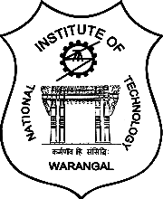

FACULTY DEVELOPMENT PROGRAMME (FDP)
on
Advanced Antennas & Designing
(9th -14th October 2017)

Organized by

Department of ECE
JNTUK College of Engineering
Kakinada
in
Association with
Electronics & ICT Academy
(MeitY, HRD Division
Govt. of India Sponsored)
N.I.T. , Warangal
Telangana State

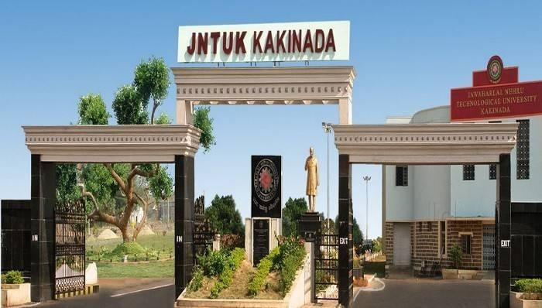

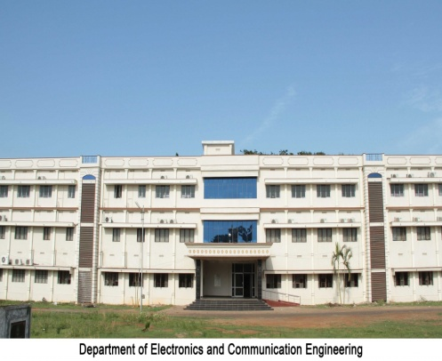

Preamble:

“Electronics & ICT Academy” is established at NIT Warangal in August 2015 with financial assistance from Ministry of Electronics and Information Technology (MeitY), GoI. The jurisdiction of this academy is Telangana, Andhra Pradesh, Andaman and Nicobar Islands, Goa, Puducherry and Karnataka states/UTs. The role of the academy is to offer faculty development programmes in standardized courses and emerging areas of Computer Science, Electronics, Information Communication Technologies; training & consultancy services for Industry; Curriculum development for Industry; CEP for working professionals; Advice and support for technical incubation and entrepreneurial activities.

About NIT Warangal:

National Institute of Technology, (formerly Regional Engineering College), Warangal is an Institute of National Importance and fully funded by MHRD, Govt. of India. It offers various programmes, B. Tech in eight branches, PG and M. Tech Programmes and also Ph.D. programmes.

About JNTUK, Kakinada:

Jawaharlal Nehru Technological University Kakinada is formed in the year 2008. JNTU College of Engineering, Kakinada, is one of the constituent colleges of this University playing a significant role since 1946 in imparting technical education in the state of Andhra Pradesh. It was a constituent college of Jawaharlal Nehru Technological University, Hyderabad and recently this Institute has been upgraded as Jawaharlal Nehru Technological University Kakinada. It is located in the coastal districts of Andhra Pradesh having nearly 260 Engineering, Management and Pharmacy institutes affiliated to this University. This college won the appreciation for judicious effective utilization of funds and implementation of the World Bank Project - TEQIP - I and was in 1st position in the state of Andhra Pradesh. TEQIP – II was also successfully implemented, with academic milestones to be scaled. Many workshops and conferences are being organized successfully to disseminate the knowledge in advances in engineering subjects.

About the host department:
Department of Electronics and Tele-communication Engineering of University College of Engineering, Kakinada was established in the year 1958 in Government Engineering College, Kakinada which was the first Department in the state of Andhra

Pradesh. Later it has been renamed as
Department of Electronics and Communication Engineering. Emphasis has been for teaching and research with equal interest. Many of the faculty members have Ph.D qualification from higher learning institutes.

This department is offering Undergraduate programme in Electronics & Communication Engineering & PG programme in Computers &Communications, Instrumentation & Control Engineering, Communications & signal processing, and VLSI & Embedded Systems. In addition, the faculty members of this department are actively involved in Research and in supervising the scholars in the areas of Antennas, Signal & Image Processing, Communications, and VLSI Design. This department has organized many workshops and conferences in advances in Electronics and Communication Engineering, with a keen interest to disseminate the knowledge to young faculty and researchers. Further, the faculty members and its alumni are mutually proud of their achievements, with research publications and also patents. The department has celebrated Golden Jubilee Year in 2008.

Major Course Contents:

Antenna Basics, HF-VHF Antennas, Patch Antennas, CPW Based antenna design, Fractal Antennas, Meta-materials for antennas etc. There will be hands on sessions on software tools.

Eligibility:

The programme is open to the teachers of Engineering colleges, and other allied disciplines in Telangana, Andhra Pradesh, Karnataka states and Pondicherry, Andaman and Nicobar Islands, Lakshadweep UTs. Scientists, engineers and other working Professionals are also eligible.

Registration Fee Particulars:

- Faculty and Research Scholars from above mentioned states: Rs 2500/-(inclusive of boarding & lodging)
- Faculty of SC/ST Category from above mentioned states: Rs 1250/- ( Submit the Caste Certificate along with Application)
- Industry participants: Rs 7500/-(inclusive of boarding & lodging)
- Participants from other than above mentioned states/UTs : Rs 8500/- Only (inclusive of boarding & lodging)

The participants need to send a crossed demand draft (DD) drawn in favor of "Director, NIT Warangal" and payable at SBI, NIT Warangal branch or transfer online to the account “ Electronics &ICT Academy, NITW”, Account No: 62423775910 with IFSC Code: SBIN 0020149 and mail the transaction details.

Accommodation :

No TA/DA will be paid to the participants.
Accommodation and boarding will be provided on prior request with free of cost.

How to apply :

A filled-in form of application in the prescribed format duly signed and sponsored by appropriate authorities (along with demand draft) should reach the coordinator
on or before the last date by post/courier. Participants are requested to write their name and contact number on the backside of demand draft. It is also mandatory to send scanned application form and demand draft through e-mail to: fdp_antennas2017@ gmail.com. The selection will be intimated only through e-mail.

Selection Criteria :

Selection will be done based on first-cum-first-serve basis and the confirmed candidates will be notified by email. The maximum number of participants will be 50 (fifty). Additionally 10 participants from industry are allowed to participate. The list of selected participants will be intimated through e-mail. In case a candidate is not selected, the demand draft will be sent back. Candidates will be issued certificates on successful completion of the course along with grade obtained in the grand test. Reservations of seats are followed for selecting candidates as per GOI norms.

Important dates:

Last date to receive application & Demand Draft : 30-09-2017
Selection-list intimation by email: 02-10-2017
Duration of Program : 9th – l4th October 2017

Address for correspondence:
Post your application form along with DD to
Dr. K.Rama Devi,
Asst.Professor,
Dept.of ECE, UCEK, JNTUK, Kakinada-533003, E.G(dt), A.P., India.
Contact No: 9440337658

E-mail the scanned copies of filled-in and duly signed application form along with DD to: fdpantennas2017@ gmail.com.

