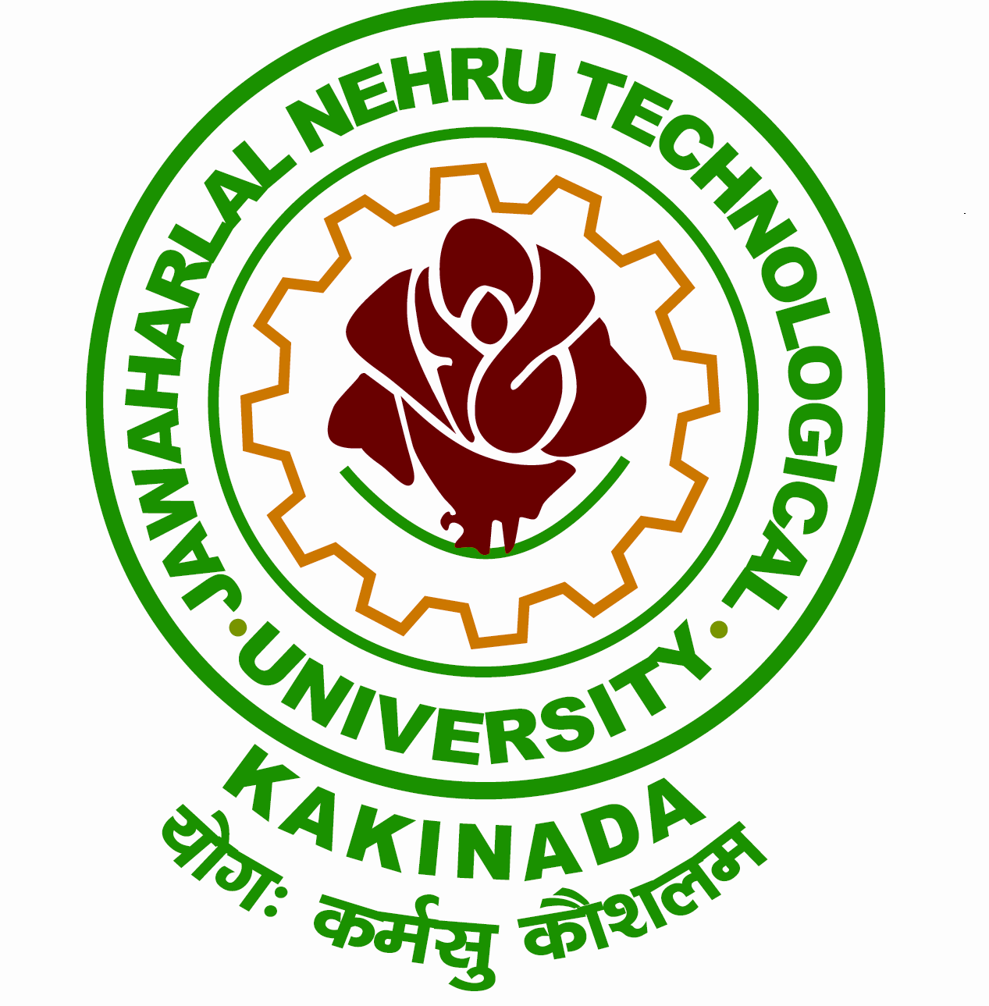
Grams: “TECHNOLOGY” Phone: Off: 0884 -2300900
Email: registrar@jntuk.edu.in Fax: 0884 -2300901
rao703@yahoo.com

JAWAHARLAL NEHRU TECHNOLOGICAL UNIVERSITY KAKINADA
KAKINADA-533003. Andhra Pradesh (India)
(Established by Andhra Pradesh Act No.30 of 2008)

Lr.No. MOOCs/ E-learning Workshop Date: 22-06-2017
Dr. V.V. Subba Rao
M.E., Ph.D.
REGISTRAR

To
The Principals of All Constituent & Affiliated Colleges
JNT University, Kakinada

CIRCULAR
************
As a part of creating awareness in E-Learning/MOOCs and Edu-Tech Tools to make class room teaching better JNTUK is organizing a “Workshop on Empowering Teaching Excellence through E-Learning Platforms" on 08th July 2017 (Saturday) at Senate Hall, JNTU Kakinada for MOOCS Single Point of Contacts( SPOCs), Internal mentors and other interested stake holders from any Institute.

Dr. Ramesh C. Sharma, Professor, Wawasan Open University,-Malaysia, Prof. P D Jose, IIM Bangalore and NPTEL Team from IIT Madras will be the resource persons for this workshop. This programme is very useful for creating awareness in MOOCs & Edu-Tech. tools for all the stake holders of the JNTUK Constituent Colleges/ Affiliated Colleges and anyone who is interested from any other Institutes. So you are requested to depute minimum two faculty members for the above Workshop by considering the importance of this work shop.
Please visit http://www.jntukwetm.in/ for further details and do Online Registration. In order to allow us to make all arrangements to the best of our ability, complete the registration by 30-06-2017.

Your earnest cooperation is solicited in making this One Day Workshop a success.
Sd/-
REGISTRAR

Copy to:
The Secretary to Hon’ble Vice-Chancellor, JNTUK
PA to the Rector, JNTUK
Director Academic Planning, JNTUK

