INTERNATIONAL COLLABORATIVE PROGRAMMES INFORMATION BOOKLET- JNTUK

Blekinge Institute of Technology (BTH) Sweden: Blekinge Institute of Technology (BTH)
is the most profiled modern university established by Government of Sweden. BTH is ranked number one in Sweden for undergraduate education in engineering, according to independent organisation Urank, which compiles ranking of Swedish universities. In systems and software engineering, BTH is ranked sixth in the world and first within the EU. There are some 70 nationalities represented on faculty level and among the students at BTH. This gives a truly international environment. Campus in two cities, Karlskrona and Karlshamn. Swedish Higher Education is ranked no.5 among the best higher education systems in the world. Blekinge Institute of Technology is located in the Blue science Park (formerly telecom city) and works closely together with Swedish Industries.Sweden is one of the world’s most innovative nations, and it has been called the most digitally connected economy. The Swedish government invests a higher proportion of GDP in R&D than most other nations. Sweden is one of the safest and
happiest nation in the world.
Offered branches, Intake, Mode of study, Award of degree at JNTU Kakinada:
Sl No. | Degree & Branch at JNTUK | Intake
1 | B.Tech Mechanical Engineering | 20
2 | B.Tech Electronics and Communication Engineering | 20
3 | B.Tech Computer Science & Engineering | 20

Mode of study and award of degree: The admitted students will study mandatory 3 years education at University College of Engineering (Autonomous) Kakinada campus and one year education at Blekinge Institute of Technology, Sweden. After successful completion of 4 years of study ,Bachelor of Technology degree will be awarded by JNTUK by accrediting the one year (two semesters) mandatory education credits (includes UG project) from Blekinge Institute of Technology, Sweden through transfer of credits to JNTUK.
Mode of cooperation with BTH: If the student opts for B.S degree after successful completion of 4 years of study, BTH Offers 60 credits of education (two semesters, one academic year) to the students enrolled in to 4 year B.Tech programme, Blekinge Institute of Technology, Sweden will provide the possibility to the students to seek a degree of “Bachelor of Science (180 ECTS Credits)”. The degree is awarded by accrediting education from JNTUK after the successful completion of the program under double degree mobility cooperation.
6 years International Collaborative Program (3+1+2) 3 Years of Study at JNTUK and (1 +2) Years of study at BTH –Sweden with exit option at the end of 4th year.

Eligible Degree from Blekinge Institute of Technology: If the student opts for award of degree from Blekinge Institute of Technology, Sweden, Bachelor of Science degree will be awarded by transferring credits from JNTUK.

Sl No. | Branch opted at JNTUK | Eligible Degree at JNTUK
1 | Mechanical Engineering  ( MECH) | B.Tech – MECH (or) B.S - Mechanical Engineering
2 | Electronics and Communication Engineering (ECE) | B.Tech – ECE (or) B.S - Telecommunications Systems
3 | Computer Science & Engineering (CSE) | B.Tech – CSE (or) B.S – Computer Science (or)  B.S– Software Engineering
Tuition Fee:
Collaborative Universities | Branch & Intake | Tuition Fee | Remarks
JNTUK  and  Blekinge Institute of Technology (BTH) SWEDEN) | ECE(20) | Rs. 1,50,000/- for the first 3 years  35000 +35000⁴ = 70000 SEK for the 4th year  5th & 6th years(M.S studies)* | Visa, Travel and Living Expenses shall be borne by the students⁵
 | CSE(20)
 | ME(20)
* MS Program Tuition fee: The tuition fee level of free mover international students³ (adopted during the year of admission) at BTH will be applicable to the master’s studies.
- The admission is based on the rank obtained in the JEE Mains/ AP , TS EAMCET -2017
- If minimum number of students are not admitted the programme will not be offered.
- After completion of four years degree, the candidate willing to pursue two years master degree at BTH Sweden, he/she has to submit a separate application (see section 8).
- Candidate has to pay 4th year 1st semester tuition fee 35000 SEK directly to BTH Sweden before the commencement of Visa Processing which starts in 3rd Year II Semester. However 4th year second semester tuition fee need to pay in BTH Sweden before commencement of second semester.

- Visa Requirements and Accommodation:

Students should be able to fund their travel & living expenses for the stay at Sweden. Students should be able to show a minimum financial requirement of SEK 8010 (Sweden Kronas) per month for the entire planned study period at Sweden. Documentation certifying one’s own must be provided at the time of applying residence permit (VISA).For 12 Months stay in Sweden, the students should show minimum financial requirement of SEK 80100, Approx. INR 6.40 Lakhs (As per the present currency exchange rate*) before Swedish Migration Board while applying for VISA (Student Residence Permit). For further details please visit www.migrationsverket.se
Accommodation at BTH: The average accommodation cost will be around 40000 SEK / Annum during the study period at BTH, Sweden on sharing basis.
Note: Students are responsible to show the required financial proofs to the migration authorities while applying for student permit (VISA). Either BTH or JNTUK will not be responsible for the VISA rejections caused on the grounds of in-sufficient financial funds/statements in front of Migration Board. Students have to adhere to migrations regulations.
- Scholarships (Tuition fee waiver) at BTH:
The students enrolled will be eligible to apply for BTH Scholarships (tuition waivers). The scholarship recipient will have the possibility to reduce the tuition fee. The selection is done based on merit through global competition.
- Capacity Building programme (optional):
Capacity Building Programme for Global Employability and Entrepreneurship (CBPEE, 15 credits), The CBPEE is designed with direct inputs / in close cooperation with Swedish Industry and it will be offered in addition to the agreed educational plan. The programme will result in up skilling the students with necessary practical and employable skills to meet the expectations from the industry and the knowledge for starting a startup companies. The programme is recommended for the students who want to exit with bachelor degree at BTH. The fee for these credits will be equivalent to the fees charged for international free mover student⁴. The exact fee for the training will be communicated during the year of admission to the BTH. The estimated fee for the training can vary between 17500 – 25000 SEK.

- After Bachelor studies:
A) Admission to Master’s Programmes:
The students from JNTUK are provided with a provision to apply to the masters programs, i.e. two year master programmes at BTH after the completion of their bachelor education in relevant specialization. In such case, the tuition fee level of free mover international students (adopted during the year of admission) will applicable to the master’s studies.The students can also apply for BTH Scholarship (tuition waiver) while making an application to the master studies. The students are selected based on merit among all the prospective international students who apply to BTH for masters studies.

B) Seeking career in Sweden:
The successfully completed students are eligible to extend their residence permit for six months in-order to seek employment or explore the posibilitéis of starting by their own business as per the regulations of migration board. For more details visit: www.migrationsverket.se

List of some of the successful JNTUKAKINADA students who are working in companies in Sweden / Europe after completing the collaborative education at BTH, i.e. students graduated in 2016
SL.NO | NAME | PICTURE | COMPANY | COUNTRY
1 | DIVYA PEDDI REDDY |  |  | SWEDEN
2 | RAYWON TEJA | 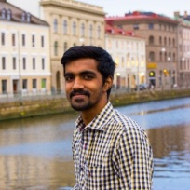 |  | SWEDEN
3 | VisHNU MANASA | 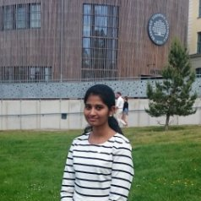 | 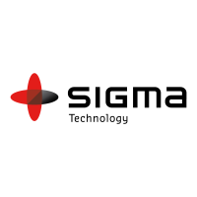 | SWEDEN
4 | SRIKAR REDDY | 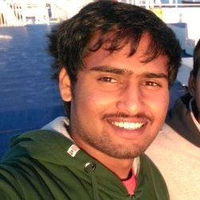 |  | SWEDEN
5 | SINDHURA CHILAKAPATI | 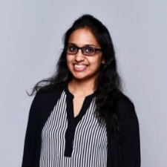 |  | SWEDEN
6 | MANITEJA DARSIPUDI | 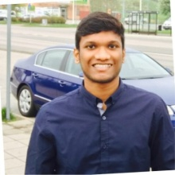 |  | SWEDEN
7 | MUKESH | 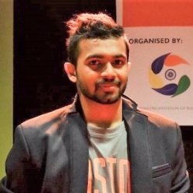 |  | SWEDEN
8 | LAKSHMI SOWJANYA NEKKANTI |  |  | SWEDEN
9 | GANESH GRANDHI |  |  | SWEDEN
10 | TULASI PRIYANKA SANABOYI | 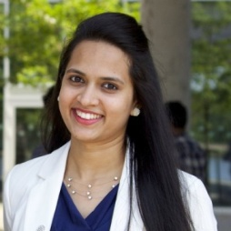 |  | SWEDEN
11 | NUNNA TEJASWINI |  |  | SWEDEN
12 | RATNA P GARIGAPATI |  |  | SWEDEN
13 | PAVAN KUMAR NANDURU | 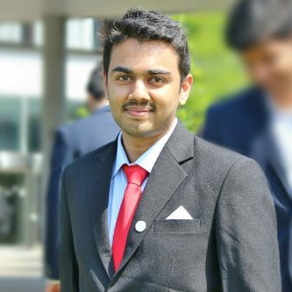 |  | SWEDEN

Asian Institute of Technology (AIT) BANGKOK:
Asian Institute of Technology (AIT), Bangkok, Thailand: Asian Institute of Technology (AIT), situated north of metropolitan Bangkok, Thailand, is a international postgraduate institution of engineering and technology, environmental resources and development, and management which is established in 1959 to promote technological changes and sustainable development in the Asia and Pacific region through higher education, research, outreach and capacity development. The Institute is comprised of the School of Engineering and Technology, the School of Environment, Resources and Development, the School of Management, more than 30 established postgraduate programs, several research and outreach centers, and a continuing professional development center called the AIT Extension. As a multicultural and multinational educational hub for a global network of development partners, AIT is dedicated to the generation and transfer of knowledge, and the strengthening of capacity across borders.
Tuition fee JNTUK & AIT – Bangkok:
6 years International Collaborative Program (3+1+2) 3 Years of Study at JNTUK and (1 +2) Years of study at AIT –Bangkok with exit option at the end of 4th year.
Collaborative Universities | Degrees awarded | Branch & Intake | Master‘s Specialization  ( Intake) | Tuition Fee Rupees | Remarks
JNTUK  and  Asian Institute of Technology (AIT) Bangkok ) | At the end of 4th year, Bachelor Degree will be awarded after fulfilling all the academic requirements. | CIVIL (20) | Specializations will be made available shortly as soon as received from AIT – Bangkok. | Rs. 1,50,000/- for the first 3 years to JNTUK and  for the 4th year , and 5th & 6th years(M.S studies)* fee will be made available shortly as soon as received from AIT –Bangkok) in (xxxxx) Bahts | Visa, Travel and Living Expenses shall be borne by the students
 |  | EEE (20)
 |  | ME (20)
 |  | ECE (20)
 |  | CSE (20)
* ME Program Specializations & Tuition fee along with 4th year tuition fee will be provided as soon as received from AIT – Bangkok.
- The admission is based on the rank obtained in the JEE Mains/ AP& TS EAMCET -2017
- If minimum number of students are not admitted the programme will not be offered.
- Candidate has to pay 4th year 1st semester tuition fee xxxx in Bhats directly to AIT Bangkok before the commencement of Visa Processing which starts in 3rd Year II Semester. However 4th year second semester tuition fee need to pay in AIT before commencement of second semester.
- After completion of four years degree, the candidate willing to pursue two years master
degree at AIT Bangkok, he/she has to submit a separate application.
- Master’s Specialization and 4th , 5th and 6th year Tuition fee details of AIT-Bangkok will be made available shortly as soon as received from AIT-Bangkok..
Important contacts:
A) JNTU Kakinada:
- Dr. M. Ramalinga Raju, Director of Admissions Jawaharlal Nehru Technological University Kakinada, Kakinada Ph:+ 0884 2340356, Email : dajntukakinada@gmail.com
- Dr. V.V.Subba Rao, Director of Foreign Universities Relations, Jawaharlal Nehru Technological University Kakinada, Kakinada Ph: 0884 2300914, Email:dfur@jntuk.edu.in
B) Blekinge Institute of Technology:
- Gurudutt Velpula, Director - India Initiatives, Blekinge Institute of Technology Karlskrona, Sweden. + 46- 734 - 405670 ( Sweden) + 46- 455385212 + 91- 9959-405670 ( India) Email :gurudutt.velpula@bth.se,

For practical information, Visa requirements etc:
- Mr.Phani Sekhar, Local coordinator for BTH, International Students in Real Life : +91-9032011127, phanisekharg@icloud.com

c) Asian Institute of Technology:
- Dr. Nitin Kumar Tripathi, Director - Special Degree Programs, Asian Institute of Technology, P.O. Box: 44, Klong Luang, Pathumthani 12120, Thailand, Phone: +66-886021115 (Mobile), Email: nitingis@gmail.com.

https://www.bth.se/eng/about-bth/facts-and-figures/
http://www.universitas21.com/article/projects/details/152/u21-ranking-of-national-higher-education-systems-2017
Offered in the year of admission
The current tuition fee (for academic year 2017 at BTH) for free mover international students is 50 000 SEK / semester. The current fee can reduce / increase to meet the actual cost for the tuition.
The salary level will be 23000 SEK – 30000 SEK / month based on the roles. The salary for doctoral position is 27000 SEK / month.

