Grams: “TECHNOLOGY” Phone: Off: 0884 -2300900
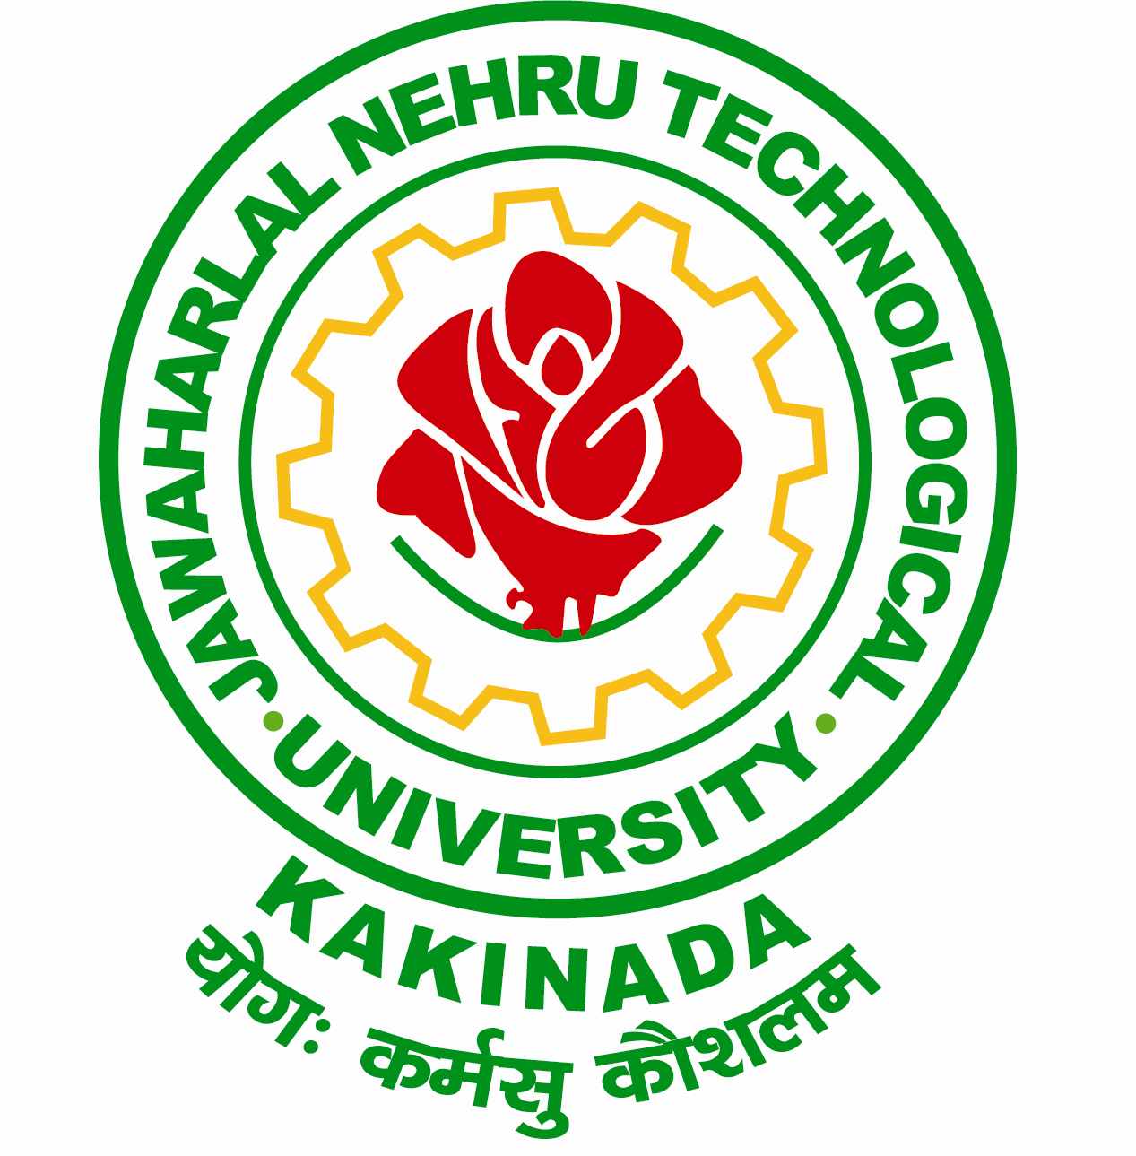
Email: registrar@jntuk.edu.in Fax: 0884 -2300901
chs_eee@yahoo.co.in
JAWAHARLAL NEHRU TECHNOLOGICAL UNIVERSITY KAKINADA
KAKINADA-533003, Andhra Pradesh (India)
Lr. Registrar Peshi/USC/ Reschedule of Inter Collegiate Tournament/ 2016-17, DT: 06-02-2017

Prof. Ch. Sai Babu
M.Tech., Ph.D.
REGISTRAR i/c

To
The Principals
Constituent / Affiliated Colleges
JNTU Kakinada

Sir,
Sub: - JNTUK- University Sports Council – Reschedule of Zone-B Inter Collegiate
Tournament for the academic year 2016-17– Regarding.
***
I am by the direction, wish to inform to you that the following Inter Collegiate tournament
is rescheduled. The details are given under:
S.No | Zone | Name of the Organizing College | Revised Dates
 | Zone–B  Inter Collegiate Tournament | Godavari Institute of Engineering & Technology, Rajahmundry, E.G.Dist  Organizing. Secretary: Dr. Ch. Manajrekar Henry,  Cell No: 9000158888 | 14th – 15th February, 2017
Concerned Principal, of the college to which the event is allotted is requested to monitor the necessary arrangements for smooth conduct of the Tournament. Please contact concerned Organizing Secretary for further information regarding the tournament.

Sd/-
REGISTRAR

Copy to Secretary to Hon’ble Vice-Chancellor, JNTU Kakinada
Copy to PA to Rector, JNTU Kakinada
Copy to PA to OSD, JNTU Kakinada
Copy to Director, Academic Planning, JNTU Kakinada
Copy to Secretary, University Sports Council, JNTU Kakinada
Copy to Secretary, Inter-Collegiate Tournaments, JNTUK Kakinada
Copy to Principal, GIET, Rajahmundry

