Grams: “TECHNOLOGY” Phone: Off: 0884 -2300900
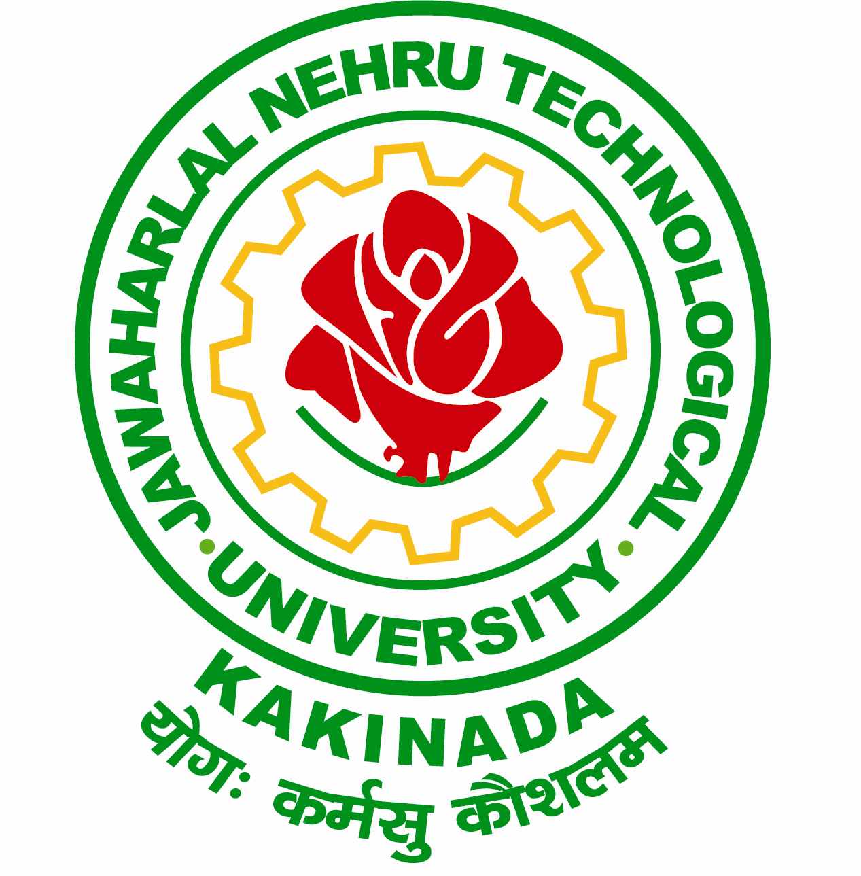
Email: registrar@jntuk.edu.in Fax: 0884 -2300901
gvrp_raju@yahoo.com,
JAWAHARLAL NEHRU TECHNOLOGICAL UNIVERSITY KAKINADA
KAKINADA-533003, Andhra Pradesh (India)
Lr. Registrar Peshi/UGSA/ Reschedule of Inter Collegiate Tournaments/ 2015-16, DT: 10-02-2016

Dr. G. V. R. PRASADA RAJU
B.E, M.E., Ph.D.
Registrar
To

The Principals
Constituent / Affiliated Colleges
JNTU Kakinada

Sir,
Sub: - JNTUK- University Games and Sports Administration – Reschedule of Inter Collegiate Tournaments for the academic year 2015-16 – Regarding.
***
I am by the direction, wish to inform to you that the following inter collegiate tournaments are rescheduled. The details are given under:
S.No | Zones | Name of the Organizing College | Revised Dates
 | Zone – B Cricket Tournament | Godavari Institute of Engineering & Technology, Rajahmundry, E.G.Dist  Org. Secretary: Dr. Ch. Manajrekar Henry,  Cell No: 9000158888 | 15th – 20th February, 2016
 | Zone- A Cricket Tournament | Raghu Engineering College, Visakhapatnam  Org. Secretary: Dr. G. Ch. Surayanarayana Raju  Cell No: 9440649945 | 16th – 20th February, 2016
 | Zone – B Games Meet for Men | University College of Engineering (Autonomous) Kakinada,  Org. Secretary: Sri. G. Syam Kumar  Contact No: 0884-2370003 | 24th – 25th February, 2016
 | Zone- D Games Meet for Men | Sri Sai Tirumala NVR Engineering College, Narasaraopet, Guntur Dist.  Org. Secretary: Sri. N. Lourdhu Raju,  Cell No: 9573308480 | 22nd – 23rd February, 2016
Principals of the concerned colleges are hereby requested to please note the change of dates and send your teams as per rescheduled dates. Inconvenience caused may please be regretted.
Sd/-
REGISTRAR
Copy to Secretary to Hon’ble Vice-Chancellor, JNTUK Kakinada
Copy to PA to Rector, JNTUK Kakinada
Copy to Director, Academic Planning, JNTUK Kakinada
Copy to Programme Director, GSA, JNTUK Kakinada
Copy to Secretary, University Sports Council, JNTUK Kakinada
Copy to Secretary, Inter Collegiate Tournaments, JNTUK Kakinada

