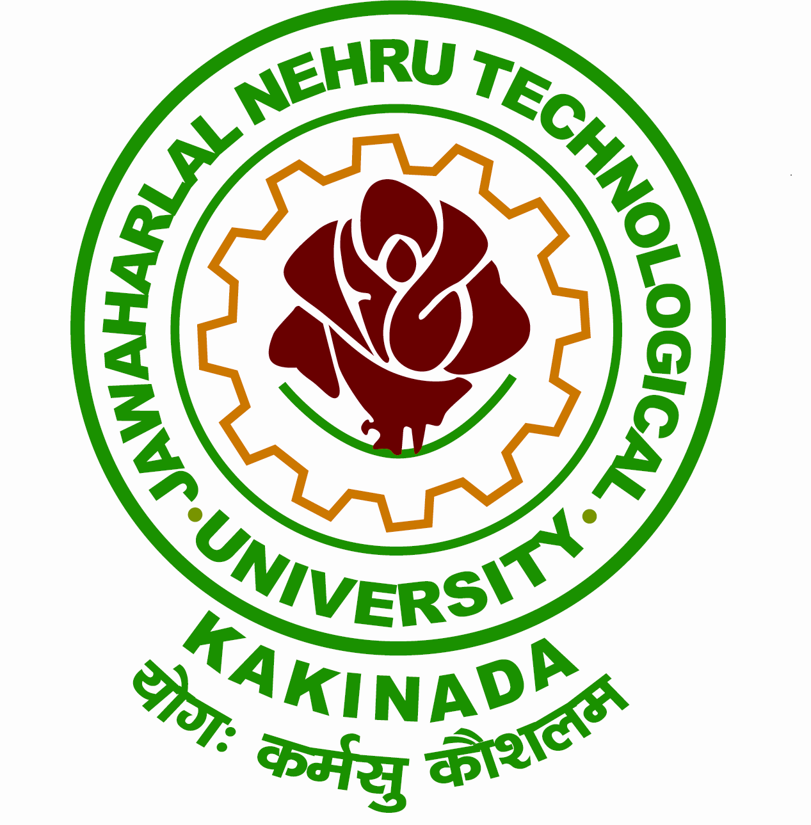
Grams: “TECHNOLOGY” Phone:Off: 0884 -2300900
Email:registrar@jntuk.edu.in Fax: 0884 -2300901

JAWAHARLAL NEHRU TECHNOLOGICAL UNIVERSITY KAKINADA
KAKINADA-533003, Andhra Pradesh (India)
(Established by Andhra Pradesh Act No. 30 of 2008)

------------------------------------------------------------------------------------------------------------------

Lr. No. JNTUK/RP/Prathibha awards 2015-16/2016 Date: 01.10.2016

Dr. Ch. Sai Babu,
M. Tech, Ph.D.
REGISTRAR i/c

To
The Principals of Constituent/Affiliated Colleges,
JNTUK, Kakinada.

Sir,

Sub: - JNTUK – APSCHE – PRATIBHA AWARDS for Meritorious Students of Post- Graduation studying in the Colleges for the year 2015-16 – List of merit
Candidates in each category and course – Reg.
Ref: - 1. G.O.Rt. No. 121, Higher Education (TE) Department, dated 06.04.2015.
2. Lr. Rc. No. 162/OP.III & Scholarship/2016, dated 27.09.2016 of the
Commissioner of Technical Education, Govt., of Andhra Pradesh, Hyderabad.

****
Please find enclosed herewith the copy of letter along with enclosure (ref. 2), in connection with the “PRATIBHA AWARDS for Meritorious Students” for the year 2015-16.

In this connection, I am by direction, request you to furnish the required information in the prescribed proforma, in both soft & hard copies, on or before 03.10.2016.

The above information may be furnished directly to the AP State Council of Higher Education, Hyderabad, under intimation to this office.

Yours sincerely,
Encl: as above

REGISTRAR i/c

Copy to the Director, Academic & Planning, JNTUK for information.
Copy to the Secretary to Hon’ble Vice-Chancellor, JNTUK, Kakinada.
Copy to the PA to Rector, JNTUK, Kakinada.
Copy to the PA to Registrar, JNTUK, Kakinada.
Copy to the PA to OSD, JNTUK.

